Purpose of this Equipment: To provide a commercial grade table top slicer to slice delicatessen meats and cheeses both manually and automatically.

- Federal Supply Class: 7320

- General Operating Specifications:

  - Dimensions:
    - 30 inches long / wide, 32 inches deep, 28 inches high. Dimensional sizes, such as length, width, and height can vary no more than + / - 6 inches. This equipment is to be a table top model.
    - Minimum 13 inch alloy steel blade / knife, not to exceed 13.75 inches

  - Salient Characteristics that shall be provided:
    - Stainless steel or aluminum carriage with no crevice in carriage and fence / baffle plate (figure 1)
    - One-piece base with limited crevices or bolt holes
    - Minimum 0.5 Horsepower (HP) motor
    - Minimum speed 40 slices per minute
    - Accepts minimum product size of 10 inches in width and 7 inches in diameter
    - Slices meat or cheese products to a thickness from 0 to 0.9 inches
    - Automatic and manual modes
    - Product slicing action by gravity feed Biro
    - Non-removable blade
    - Ring / thumb guard
    - Removable blade sharpening system
    - No volt release: slicer must be restarted in the event of a power loss
    - Zero blade exposure for cleaning
    - Removable Carriage

Industry Standards / Requirement(s):
    - Industry Standards: Underwriters Laboratory (UL) listed and National Sanitation Foundation (NSF) (8) certification, or approved equivalent. CE is not acceptable for a standard.
    - Warranty period shall be for (1) year from date of delivery against defective material and workmanship and shall include parts, service and labor.

  - Information Technology requirements: N / A

Color Requirement(s): N / A

- Electrical Requirements:

_____ Standard U.S.A. electrical specifications: 120 volts, 60 Hertz, 1 phase.

_____ Pacific Theater stores 120 V / 50 HZ / 1 PH (Applies to these stores only: Atsugi, Misawa, Sagami, Sagamihara, Yokosuka, Yokota, Camp Zama, and Kanto Plains CDC. All other stores are standard U.S.A. 60 cycle voltages.)

Minimum 6 foot cord with a NEMA Standard plug, or a manufacturer’s equivalent to comply with the equipment plug in requirements.

NOTE: the operating range for 120 volts is 110 to 120 volts; the operating range for 220 volts is 208 to 230 volts.

Standard Contractor Requirements:
  - Must be shipped ready to assemble, plug in, and use
  - Information to be provided by the Contractor to the commissary at the time of delivery:
    - Point of Contact for Service
    - Installation and Operating Instructions
    - Parts List
  - Maintenance Sustainability Requirements: Continued parts support is required for the projected life cycle of the equipment plus 5 years.

Special Coordinating / Safety Instructions:

This equipment requires disposal: store personnel should place the equipment item in a specified area until DeCA’s liquidation manager gives disposition instructions to the store.

STORE ORDER REQUEST

STORE NAME: __________________________ DODAAC: ____________________

QUANTITY: _______

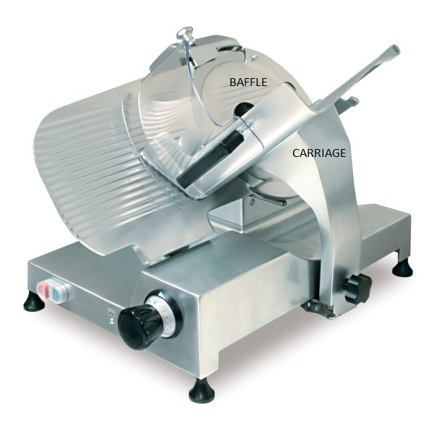

Figure 1

