- Purpose of this Equipment: To provide an executive office setting for a Commissary Store Director and / or a Zone Manager.

- Federal Supply Class: 7110

- General Operating Specifications:
  - Dimensions:
    - 1A04-A Credenza base: 68” W x 24” D x 30” H, dimension may vary +/- 1 inch.
    - 1A04-B Credenza upper: 69” W x 15” D x 53” H, dimensions may vary +/- 1 inch.
    - 1A04-C Double pedestal desk: 72” W x 36” D, 29” H, dimensions may vary +/- 1 inch.
    - 1A04-D Lateral file, 2 drawers: 35” W x 19” D x 29” H, dimension may vary
+/- 1 inch.
    - 1A04-E Lateral file, 4 drawers: 35” W x 19” D x 56” H, dimension may vary
+/- 1 inch.
    - 1A04-F Bookcase, 4 shelves: 35” W x 14” D x 52” H, dimension may vary +/- 1 inch.
    - 1A04- G Bookcase, 6 shelves: 35” W x 14" D x 82” H, dimension may vary +/- 1 inch.
    - 1A04- H Guest chair: Overall dimension NTE 24” W x 25” D x 35” H and seat height of 18 inches.

  - Salient Characteristics that shall be provided:
    - 1A04-A Credenza Base:
      - Full removable modesty panel to conceal wires.
      - Locking file drawers for letter and legal filing.
      - Surface to be constructed of hardwood and veneer.
    - 1A04-B Credenza Upper:
      - Adjustable shelf on each side.
      - Solid wood doors.
      - Upper bridge to be lighted.
      - Surface to be constructed of hardwood and veneer.
    - 1A04-C Double Pedestal Desk:
      - Full modesty panel to conceal wires.
      - Locking file drawers for letter and legal filing.
3.2.3.2 Surface to be constructed of hardwood and veneer.
    - 1A04-D and 1A04-E Lateral Files:

      - Locking file drawers for letter and legal filing.
      - Surface to be constructed of hardwood and veneer.
    - 1A04-F and 1A04-G Book Cases:
      - 4 shelf book case to have 3 adjustable shelves.
      - 6 shelf book case to have 5 adjustable shelves.
      - Surface to be constructed of hardwood and veneer.
    - 1A04-H Guest Chair:
      - Molded soft foam seat and back.
      - Upholstered back and seat.
      - Waterfall edge seat.
    - All furniture components excluding 1A04-H to be constructed of solid hardwood and veneer.
  - Industry Standards / Requirement(s):
    - Industry Standards: Underwriters Laboratory (UL) listed or approved equivalent. Conformité Européene (CE) is not acceptable for a standard.
    - Warranty period shall be for (1) year from date of delivery against defective material and workmanship and shall include parts, service and labor.

  - Information Technology requirements: N / A

  - Color Requirement(s): Furniture to be of wood tones and chairs neutral.

- Electrical Requirements:
  - Standard U.S.A. electrical specifications: 120 volts, 60 Hertz, 1 phase(s).
  - Pacific Theater stores: N / A
  - European stores: N / A
  - Minimum 6-foot cord with a NEMA Standard plug.

- Standard Contractor Requirements:
  - Must be shipped ready to assemble and use
  - Information to be provided by the Contractor to the commissary at the time of delivery:
    - Point of Contact for Service
    - Installation and Operating Instructions
    - Parts List
  - Maintenance Sustainability Requirements: Continued parts support is required for the projected life cycle of the equipment plus 5 years.

- Special Coordinating / Safety Instructions: N / A

STORE ORDER REQUEST

STORE NAME: DODAAC:

ea. 1A04-A: Credenza Base:

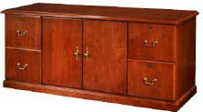
ea. 1A04-B: Credenza Upper:
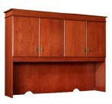

ea. 1A04-C: Double Pedestal Desk:
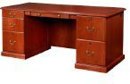

ea. 1A04-D: 2 Drawer Lateral Filing Cabinet:

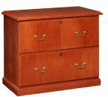

ea. 1A04- E: 4 Drawer Lateral Filing Cabinet:
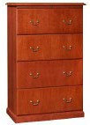

ea. 1A04-F: 3 Shelf Book Case:
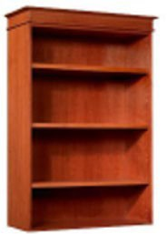

ea. 1A04-G: 6 Shelf Book Case:

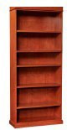

ea. 1A04-H: Guest chair with open arms and 4 legs:
