Purpose of this Equipment: To be used in the administrative office reception area

- Federal Supply Class: 7110

- General Operating Specifications:

  - Dimensions:
    - 1A07-A Chair: 32 inches long / wide, 32 inches deep, 28 inches high, dimension may vary + / - 1 inch.
    - 1A07-B Coffee Table: 40 inches long / wide, 19 inches deep, 18 inches high, dimensions may vary + / - 1 inch.
    - 1A07-C End Table: 24 inches long / wide, 18 inches deep, 22 ½ inches high, dimensions may vary + / - 1 inch.

  - Salient Characteristics that shall be provided:
    - 1A07-A Chair:
      - Fabric is nylon / latex type cloth, stain resistant
      - Seat cushions are to be extra-thick, high density foam
      - Adjustable feet to compensate for uneven floors
3.2.2 1A07-B Coffee Table:
3.2.2.1 Solid wood and veneer
3.2.3 1A07-C End Table:
3.2.3.1 Solid wood and veneer

Industry Standards / Requirement(s):
    - Warranty year shall be for (1) year from date of delivery against defective material and workmanship and shall include parts, service and labor.

  - Information Technology Requirements: N /A

Color Requirement(s):

Chair: Blue or Grey
    - Table: Mahogany

- Electrical Requirements: N /A

Standard Contractor Requirements:
  - Must be shipped ready to assemble and use.
  - Information to be provided by the Contractor to the commissary at the time of delivery:
    - Point of Contact for Warranty Service.
    - Parts List
  - Maintenance Sustainability Requirements: Continued parts support is required for the projected life cycle of the equipment plus 5 years.

Special Coordinating / Safety Instructions: N / A

STORE ORDER REQUEST

STORE NAME: __________________________ DODAAC: ____________________

______ea. 1A07-A Reception lounge chair: Blue ____ / Grey_____

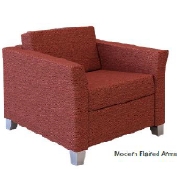

______ea. 1A07-B Coffee table

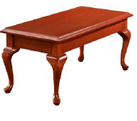

______ea. 1A07-C End table

