# Purpose of this Equipment: To provide commissary employees a standalone, modular type workstation.

1. **Federal Supply Class:** 7110
2. **General Operating Specifications:**
   1. **Dimensions:** 
      1. **1A03-A Desk Basic Workstation:** 72”W x 24”D x 65 ½”H including overhead cabinet, dimensions may vary + / - 1 inch.
      2. **1A03-B Extension Table 48”W:** 48”W x 24”D x 29”H, dimensions may vary + / - 1 inch.
      3. **1A03-C Extension Table 72”W:** 72”W x 24”D x 29”H, dimensions may vary + / - 1 inch.
      4. **1A03-D File Cabinet:** 15”W x 21 5/8D x 24 5/8”H, dimensions may vary + / - 1 inch.
      5. **1A03-E Privacy Screen 46”W:** 46”W x 31”H, dimensions may vary + / - 1 inch.
      6. **1A03-F Privacy Screen 70”W:** 70”W x31”H,dimensions may vary + / - 1 inch.
      7. **1A03-G Desk Basic**: 72”W x 24”D x 29” H, dimensions may vary + / - 1 inch.
   2. **Salient Characteristics that shall be provided:**
      1. **1A03-A Desk Basic Workstation:**
         1. Half modesty panel.
         2. Overhead cabinet to be constructed of steel with flipper-type, lockable doors.
         3. Low profile, energy efficient task light mounted flush with the bottom of the cabinet shelf.
         4. Tack board fitted between desk top and overhead.
         5. Work surface to be constructed of dense fiberboard and high-pressured laminate that covers a minimum of a 1-inch core.
         6. Work surface to have a flat smooth edge.
         7. Frame to be painted with a non-chipping, epoxy powder, enamel finish.
         8. Grommets and / or channels at back of unit to conceal wires and cables.
      2. **1A03-B and 1A03-C Extension Tables:**
         1. Work surface to be constructed of dense fiberboard and high-pressured laminate that covers a minimum of a 1-inch core.
         2. Work surface to have a flat smooth edge.
         3. Frame to be painted with a non-chipping, epoxy powder, enamel finish.
         4. Extension table adjustable height of 20 inches.
      3. **1A03-D File Cabinet:**
         1. 3 drawers that lock with a single key that match the overhead.
         2. File cabinet will have wheels, 2 locking.
         3. 12 inch drawer accommodates a letter-size mobile file and is to have a smooth rolling, full ball-bearing suspension.
         4. The 6 inch box and 3 inch pencil drawers to have rolled three quarter suspensions.
      4. **1A03-E 46” W and 1A03-F 70” W Privacy Screens:**
         1. Be able to attach to extension tables.
         2. Fabric covered and can be used as a tack board
      5. **1A03-G Desk Basic:**
         1. Half modesty panel.
         2. Work surface to be constructed of dense fiberboard and high-pressured laminate that covers a minimum of a 1-inch core.
         3. Work surface to have a flat smooth edge.
         4. Frame to be painted with a non-chipping, epoxy powder, enamel finish.
         5. Grommets and / or channels at back of unit to conceal wires and cables.

# Industry Standards / Requirement(s):

* + 1. **Industry Standards*:*** Underwriters Laboratory (UL) listed or approved equivalent. Conformité Européene (CE) is not acceptable for a standard.
    2. Warranty period shall be for (1) year from date of delivery against defective material and workmanship and shall include parts, service and labor.
  1. **Information Technology Requirements:** N / A

# Color Requirement(s): Beige or Grey.

1. **Electrical Requirements:**

# _____ Standard U.S.A. electrical specifications: 120 volts, 60 Hertz, 1 phase(s).

# _____ Pacific Theater stores: N / A

# _____ European stores: N / A

# Minimum 6 foot cord with a NEMA Standard plug.

# Standard Contractor Requirements:

* 1. Must be shipped ready to assemble, mount, plug in,and use.
  2. De-installation of old equipment is required.
  3. This equipment requires disposal: place in a specified area.
  4. **Information to be provided by the Contractor to the commissary at the time of delivery:**
     1. Point of Contact for Service
     2. Installation and Operating Instructions
     3. Parts List
  5. **Maintenance Sustainability Requirements:** Continued parts support is required for the projected life cycle of the equipment plus 5 years.

# Special Coordinating / Safety Instructions: N / A

**STORE ORDER REQUEST**

**STORE NAME: __________________________ DODAAC: ­­­­­­­­­­­­­­­­­­­­­­­­­­____________________**

**_______ea. 1A03-A Desk Basic Workstation:**

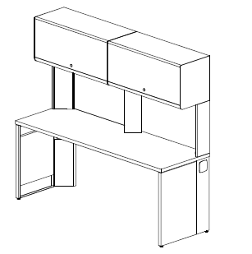

**______ea. 1A03-B Extension Table:** **48” Wide**

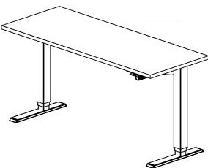



**_______ ea. 1A03-C Extension Table:** **72” Wide**





**_______ea. 1A03-D File Cabinet**

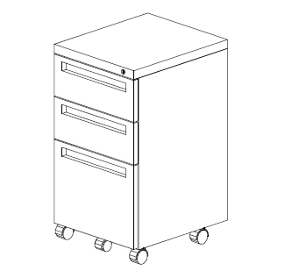

_______**ea. 1A03-E Privacy Screen 46” Wide**

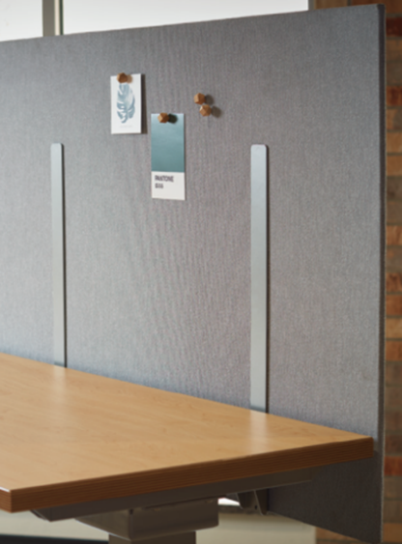

**_______ea. 1A03-F Privacy Screen: 70” Wide**



**_______ ea. 1A03-G Desk Basic**

