Purpose of this Equipment: To provide a staging area for recovering carts from the parking lot and help minimize damage to vehicles.

- Federal Supply Class: 7290

- General Operating Specifications:

  - Dimensions:
    - Units must fit inside one or two standard parking spaces (in line approximately 9ft wide by 19ft long) depending on the model selected for a specific application.

  - Salient Characteristics that shall be provided:
    - Galvanized cart rails
    - Capable of being permanently mounted if required
    - Bumper guards to protect car doors
    - High generic signage or graphic indicating cart recovery location
    - Single corral (2E11-A)
      - Minimum 20 cart capacity (20,000 cubic inch model)
    - Bi-directional corral (2E11-B)
      - Minimum 40 cart capacity (20,000 cubic inch model)
      - All parts included for bi-directional motorized cart retrieval, to include center separator bar and lane end chains.
    - Covered corral (2E11-C)
      - Minimum 30 cart capacity (20,000 cubic inch model)
      - Peaked or Rounded Roof

Industry Standards / Requirement(s):
    - Warranty period shall be for (1) year from date of delivery against defective material and workmanship and shall include parts, service and labor.

  - Information Technology Requirements: N / A

Color Requirement(s): Blue

- Electrical Requirements: N / A

Standard Contractor Requirements:
  - Must be shipped ready to assemble with common tools and unskilled labor.

  - Information to be provided by the Contractor to the commissary at the time of delivery:
    - Point of Contact for Service
    - Installation and Operating Instructions
    - Parts List

  - Maintenance Sustainability Requirements: Continued parts support is required for the projected life cycle of the equipment plus 5 years.

Special Coordinating / Safety Instructions: As required. Approval from Area Operations is required.

STORE ORDER REQUEST

STORE NAME: __________________________ DODAAC: ____________________

2E11-A______ 2E11-B_______ 2E11-C______

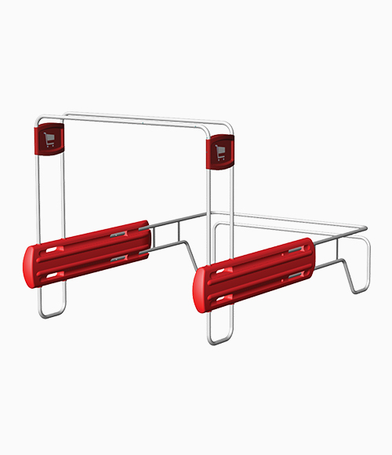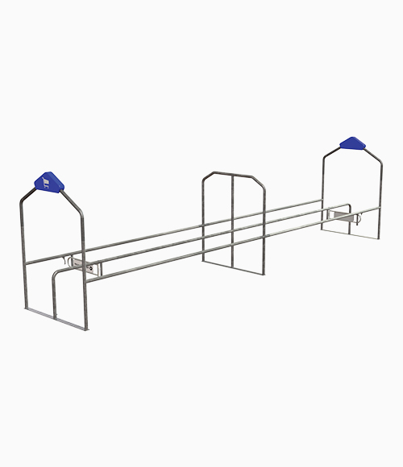
2E11-A
2E11-B

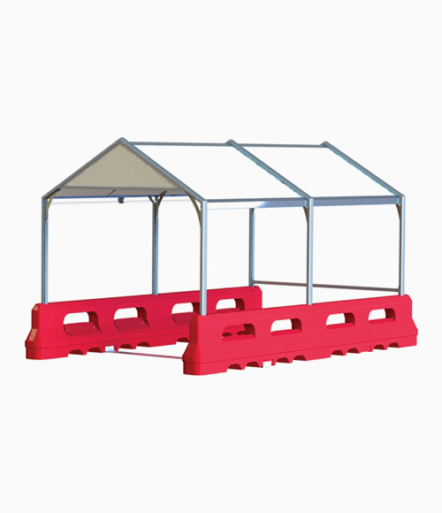

2E11-C

