Purpose of this Equipment: To provide optimum atmosphere (temperature and humidity) for proofer stage of production of bakery products.

- Federal Supply Class: 7310

- General Operating Specifications:

  - Dimensions:
    - 1B20-A (1 door): Not to exceed 100 inches high, 39 inches wide, 44 inches deep.
    - 1B20-B (2 doors): Not to exceed 100 inches high, 79 inches wide, 44 inches deep.

  - Salient Characteristics that shall be provided:
    - Stainless steel construction interior and exterior (aluminum top acceptable).
    - One rack per door only.
    - Magnetic door gaskets.
    - Insulated.
    - Interior bumpers.
    - Electronic controls for adjusting temperature and humidity.
    - Interior Light.
    - Reversible door.
    - Must be flush and level with floor.
    - Water inlet and drain connections.

Industry Standards / Requirement(s):
    - Industry Standards: Underwriters Laboratory (UL) listed and National Sanitation Foundation (NSF) certification, or approved equivalent. Conformité Européene
    - Warranty period shall be for (1) year from date of delivery against defective material and workmanship and shall include parts, service and labor.

  - Information Technology requirements: N / A

Color Requirement(s): N / A

- Electrical Requirements:
  - _____Standard U.S.A electrical specifications: 208 V/ 60 HZ/ 3 PH and
120 V/ 60 HZ/ 1 PH
  - _____U.S.A. electrical specifications: 240 V/ 60 HZ/ 3 PH and
120 V/ 60 HZ/ 1 PH
  - _____U.S.A. electrical specifications: 480 V/ 60 HZ/ 3 PH and
120 V/ 60 HZ/ 1 PH
  - _____ Pacific Theater stores 208/230 V / 50 HZ / 1 PH (Applies to these stores only: Atsugi, Misawa, Sagami, Sagamihara, Yokosuka, Yokota, Camp Zama, and Kanto Plains CDC. All other stores are standard U.S.A. 60 cycle voltages.)

NOTE: the operating range for 120 volts is 110 to 120 volts; the operating range for 220 volts is 208 to 230 volts.

Standard Contractor Requirements:
  - Must be shipped split, ready to assemble, able to fit through a 36 inch opening, make utility connections, and use.
  - De-installation of old equipment is required.
  - This equipment requires disposal: Contractor to remove from commissary and dispose.
  - Installation required by an authorized service technician.
  - Operational testing is required.
  - Startup assistance required.
  - Provide familiarization training.
  - Information to be provided by the Contractor to the commissary at the time of delivery:
    - Point of Contact for Service
    - Installation and Operating Instructions
    - Parts List
  - Maintenance Sustainability Requirements: Continued parts support is required for the projected life cycle of the equipment plus 5 years.

Special Coordinating / Safety Instructions: De-installation of existing proofer and removal from premises for disposal is requested.

STORE ORDER REQUEST

STORE NAME: __________________________ DODAAC: ____________________

SINGLE OR DOUBLE: _________ QUANTITY: _______

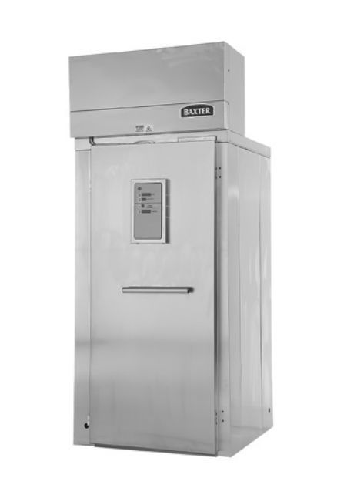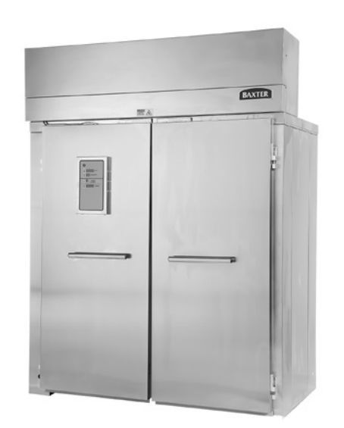
- DOOR: RIGHT HAND____________________, LEFT HAND________________

- DRAIN LOCATED FRONT________________, REAR_______________________

- ADDITIONAL RACKS: ___________________

- CURRENT PROOFER TO BE REMOVED:

MANUFACTURER______________________ BARCODE____________________

SERIAL NUMBER_______________________ MFR YEAR___________________

