- Purpose of this Equipment: To trim, cut and de-bone meat items for special orders and for special wrapping.

- Federal Supply Class: 7320

- General Operating Specifications:

  - Dimensions:
    - 4TMP-4: 48 inches long / wide, 30 inches deep, 34 inches high. Dimensional sizes, such as length, width, and height should not vary more than a plus or minus 2 inches.
    - 4TMP-6: 72 inches long / wide, 30 inches deep, 34 inches high. Dimensional sizes, such as length, width, and height should not vary more than a plus or minus 2 inches.

  - Salient Characteristics that shall be provided:
    - Table and optional understructure shall be 16 gauge, 300 series stainless steel
    - Legs to be stainless steel and a minimum of 1 5/8 inches diameter, with adjustable bullet feet
    - Cutting surface is minimum 0.60 inch thick polyethylene
    - Reversible polyethylene boards to come in two or three sections, depending on the length of the table
    - Polyethylene boards to be dishwasher-safe and able to be steam cleaned at temperatures up to 180 degrees Fahrenheit without damaging the finish
    - Tabletop is an open frame with the polyethylene boards resting on hat channels
    - Corner tabs or similar means to hold polyethylene boards securely in place
    - Shipped fully assembled
    - Optional pan / boat racks, either wall or table mount
    - Optional back splash

Industry Standards / Requirement(s):
    - National Sanitation Foundation (NSF) certification, or equivalent.
    - Warranty period shall be for (1) year from date of delivery/installation against defective material and workmanship and shall include parts, service and labor.

  - Information Technology requirements: N / A

Color Requirement(s): N / A

- Electrical Requirements: N / A

Standard Contractor Requirements:
  - Must be shipped assembled and ready to use
  - Information to be provided by the Contractor to the commissary at the time of delivery:
    - Point of Contact for Service
    - Installation and Operating Instructions
    - Parts List
  - Maintenance Sustainability Requirements: Continued parts support is required for the projected life cycle of the equipment plus 5 years.

Special Coordinating Instructions: N / A

STORE ORDER REQUEST

STORE NAME: __________________________ DODAAC: ____________________

QUANTITY: _______

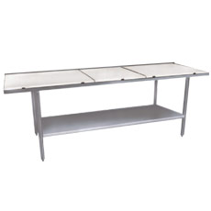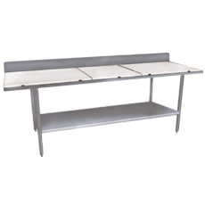

  - 4 TMP-4 (4 foot)
_______ Optional under-shelf.
_______ Optional boat rack (wall mount style)
_______ Optional boat rack (table mount style)
_______ Optional backsplash

  - 4TMP-6 (6 foot)
_______ Optional under-shelf.
_______ Optional boat rack (wall mount style)
_______ Optional boat rack (table mount style)
_______ Optional backsplash

