Purpose of this Equipment: To safely store flammable liquids in centralized area.

- Federal Supply Class: 7125

- General Operating Specifications:

  - Dimensions:
    - 2R00-A (30 gallon) capacity: 43 inches long / wide,18 inches deep, 44 inches high.
    - 2R00-B (45 gallon) capacity: 43 inches long / wide, 18 inches deep, 65 inches high.
    - 2R00-C (60 gallon) capacity: 34 inches long / wide, 34 inches deep, 65 inches high.

  - Salient Characteristics that shall be provided:
    - Double-walled, minimum 18 gauge steel
    - Adjustable leveling feet
    - Built-in grounding connector for a secure ground wire connection
    - Dual vents with integral metal flash arresters to prevent accidental ignition
    - Liquid-tight 2 inch bottom well to prevent leakage
    - Self-closing doors with a 3 point closure mechanism with lock and keys
    - Adjustable shelves for various sized containers

Industry Standards / Requirement(s):
    - Industry Standards: Requires compliance with the Occupational Safety and Health Administration (OSHA) standard 1910.106, flammable and combustible liquids, and the National Board of Fire Underwriters flammable and combustible liquid code 30 as recommended by the National Fire Protection Association (NFPA).
    - Warranty period shall be for (1) year from date of delivery/installation against defective material and workmanship and shall include parts, service and labor.

  - Information Technology requirements: N / A

Color Requirement(s): Safety yellow with red lettering.

- Electrical Requirements: N / A

Standard Contractor Requirements:
  - Must be shipped ready to use.
  - Information to be provided by the Contractor to the commissary at the time of delivery:
    - Commercial Point of Contact for Service
    - Installation and Operating Instructions
    - Parts List.

Special Coordinating / Safety Instructions:
  - Store: This cabinet(s) should be placed outside at least 50 feet from the commissary building or as directed by the local installation Fire Department.

STORE ORDER REQUEST

STORE NAME: __________________________ DODAAC: ____________________

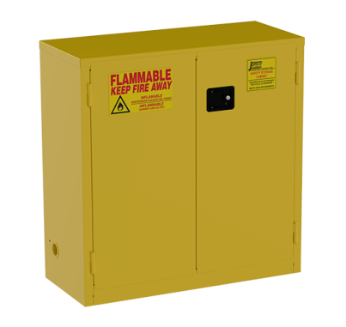30 gallon: _____
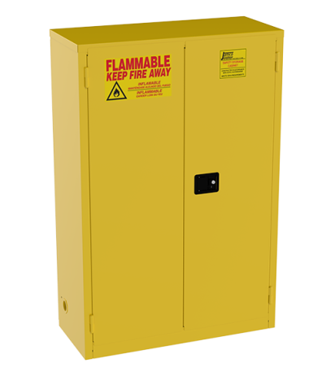45 gallon: _____
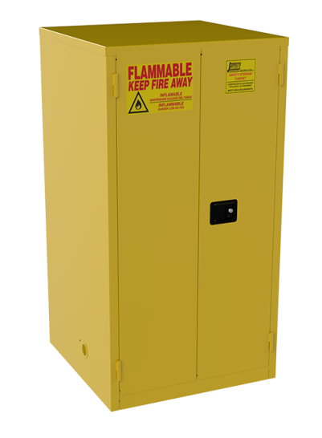60 gallon: _____

